Attention page
- Do not show risks open that have a due date that is more than one week away.
- Do not duplicate the same entry twice i.e. the same risk because it has a high exposure and there are missing steps in the lifecycle.
Report
In a page when there is not a lot of information leave more space (standard spacing) between sections for
- Risk Cockpit & Attention and Escalated Risks
- Decision Cockpit & Attention, Decision Queue and Recent Decision outcomes
Put Workstreams and Milestones cockpits together in one page with separation.
The new introduced tick marks and bullets point look good and elegant in pdf because there is some space between the bullet and the text starting point while in ppt it looks crowded. I thought we had standard functions for all these. It is not the same.
Pdf good
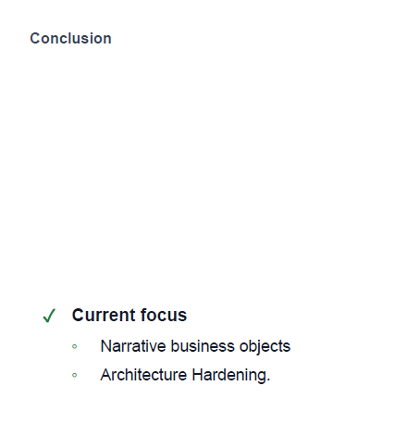
PPT crowded
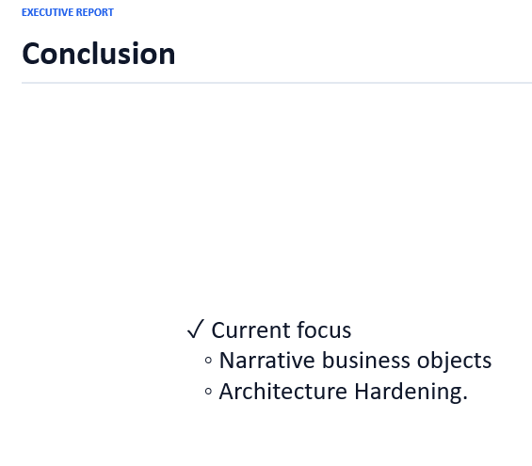
Natural language understanding
The natural language recognition is not working properly on the laptop and on mobile. i.e. It recognized finally phase 7 and told me there was no workstream eligible although it showed the Narrative business object below.

In Timetracking create download of time entries in Excel so that I can create adhoc reports.

In the new One page Executive Briefing we will need the collapse button to only show phases. We need to reduce all the row width of the Gantt to 1/3 to be able to feed everything in one page.
In the section of Delivery status the summary line 41 workstreams completed and 12 milestones completed is redundant.
I would remove the Attention section completely as this is only an attention place for the PM.
Here we can put the Project Pulse section and place the completed workstreams, milestones, closed risks, escalations in vertical with the same standard boxes of the rest of the cockpits. This will give us more space.
Changing : and ; allows me to change the appearance on the page. It works great.

